# About the Hands-on Lab Exercises

Power BI Developer in a Day (DEVINADAY) includes a rich set of hands-on lab exercises designed to reinforce the key concepts and techniques that you learned about in the lectures. The lab exercises for Power BI Developer in a Day workshop were designed to run on a student workstation running Windows 10 or Windows 8.1.

### GitHub Repository for this Workshop

Student files for this course are maintained in a GitHub fil repository at https://github.com/CriticalPathTraining/DevInADay.

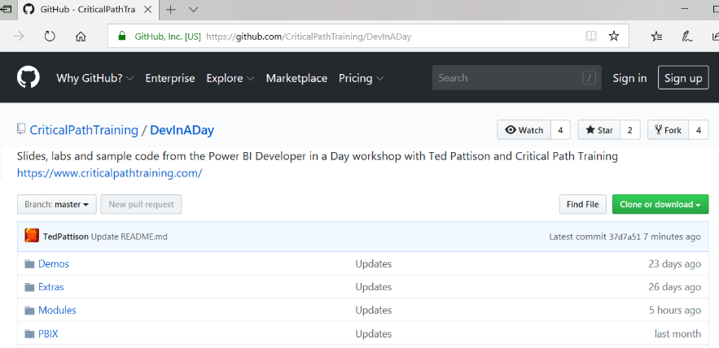

### Setting Up for the Workshop's Hands-on Lab Exercises

Students are required to bring a Windows PC and to install developer software according to the [workshop setup guide](https://github.com/CriticalPathTraining/DevInADay/raw/master/Setup.docx).

### Downloading a Local Copy of the Student Files

Exercise 1 of the first lab will step you through downloading the student files for this workshop. If you have the GIT utility installed, you can follow these steps to copy the student files to your Windows PC.

1. Open up a Windows PowerShell command prompt.
2. Type in and execute the following **git** command to download the student files to a local folder named **C:\Student**. Note that you copied the URL to github.com in the previous step and you can paste it from the Windows clipboard instead of typing it it.

git clone https://github.com/CriticalPathTraining/DevInADay.git C:\Student

1. When the **git clone** command runs, it will create a local copy of the repository on your local machine in the **C:\Student** folder.
2. When the **git clone** command completes, open Windows Explorer and examine the **Student** folder. You should be able to see the **Student** folder has child folders named **Extras**, **Modules**, **PBIX** and **Scripts**.

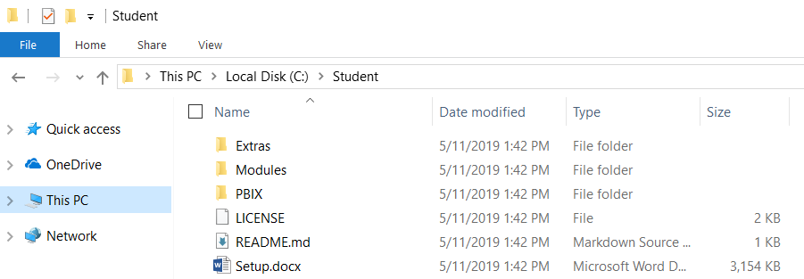

1. Drill into the **Modules** folder and locate the child folder inside named **01_GettingStarted**.

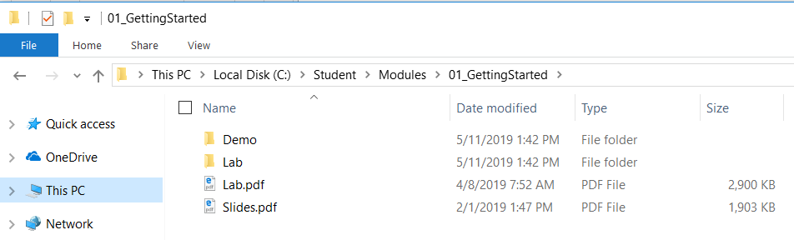

You can see that the **01_GettingStarted** folder contains folders named **Demo** and **Lab** as well as **Lab.pdf** and **Slides.pdf**